**AUTONOMOUS HR AGENT**

**PROJECT SYNOPSIS**

OF MINOR PROJECT

PHASE-II

6th Semester

# BACHELOR OF TECHNOLOGY

COMPUTER SCIENCE AND ENGINEERING (AI &AI ML)

## SUBMITTED BY

**Anurag Yadav** - 301310922041

**Anmol Kumar** - 301310922020

**Supriya Dhara**- 301310922009

**S. Nimmi**- 301310922114

## Session 2024-2025



**RUNGTA COLLEGE OF ENGINEERING AND TECHNOLOGY BHILAI(C.G)**

## Rungta College of Engineering and Technology, Bhilai Department of CSE -AI/AIML

**Table of Contents**

|  |
| --- |
| **S.No. Title Page No.** |
|  |
| 1. 1. Introduction 03 |
|  |
| 1. 2. Rationale Behind the Study 04 |
|  |
| 1. 3. Literature Review 05 |
|  |
| 1. 4. Objective 06 |
|  |
| 1. 5. Feasibility Study 07 |
|  |
| 1. 6. Methodology/ Planning of work 08-09 |
|  |
| 1. 7. Flow Chart 10 |
|  |
| 1. 8. Expected Outcomes 11 |
| 9. References 12 |

**Guide Name**

**Dr. Padmavati Shrivastava**

HOD **CSE(AI/AIML)**

**Consent of Guide**

**Suggestions by the guide:**

**B. Tech Project Synopsis**

**Introduction:**

The Autonomous HR Agent project involves automating key HR processes like job application screening, resume parsing, candidate ranking, and initial interviews. By integrating Large Language Models (LLMs) and function calling, this agent goes beyond traditional rule-based systems. It can now parse resumes using Natural Language Processing (NLP), extract relevant details (skills, experience, education), match them against job descriptions, and even initiate dynamic function calls to schedule interviews or rank candidates.

The agent can conduct the initial interview stages using LLM-based conversational AI, enabling it to pose HR-specific questions, interpret candidate responses, and evaluate their suitability. This agent can use sentiment analysis and context-aware AI to adjust interview questions dynamically.

HR technology leaders foresee AI’s growing role in a variety of areas, such as aiding recruitment, improving compliance, augmenting training, streamlining onboarding and more. New artificial intelligence technologies that automate and

augment the workforce could be the key to solving some of the thorny issues and increased demands for HR to accomplish more with fewer resources.

**Rationale Behind the Study:**

The Autonomous HR Agent project addresses key inefficiencies and challenges in modern recruitment processes by leveraging AI-driven automation. Traditional HR workflows, especially in talent acquisition, involve labour-intensive tasks such as resume screening, candidate shortlisting, and initial interviews. These processes can be time-consuming, prone to human biases, and inefficient when dealing with large applicant pools. The rationale behind this study is to explore how Large Language Models (LLMs), Natural Language Processing (NLP), and Machine Learning (ML) can optimize recruitment, reduce bias, and improve hiring efficiency**.**

**Key Reasons for Conducting the Study:**

* **Enhancing Recruitment Efficiency**

HR professionals spend significant time manually reviewing resumes and conducting preliminary interviews. AI-powered automation can drastically reduce this workload, allowing HR teams to focus on higher-value tasks such as strategic workforce planning and employee engagement.

* **Reducing Human Bias in Hiring**

Traditional recruitment is susceptible to unconscious bias, where candidates may be judged based on name, gender, or background rather than qualifications.

* **Improving Candidate Experience**

A common challenge in recruitment is delayed responses and poor communication with applicants. The AI agent can instantly acknowledge applications, provide feedback, and schedule interviews, ensuring a seamless experience for job seekers.

|  |  |  |  |  |  |  |  |
| --- | --- | --- | --- | --- | --- | --- | --- |
| S.No. | Author’s  Name | Title | Source | Y  e  a  r | Methodology | Findings | Gaps |
| 1. | Nishad Nawaz, Hemalatha Arunachalam, Barani  Kumari Pathi & Vijayakumar Gajenderan. | The Adoption of Artificial Intelligence in Human Resources Management Practices. | International Journal of Information Management Data Insights. | 2  0  2  4 | The study uses a descriptive research design, collecting primary data from 274 IT employees in Chennai via a structured questionnaire and secondary data from journals. Convenience sampling and online surveys were conducted from May to September 2021. | This research can continue by focusing on automated interviews and  implementation and working in different non IT sector. | 1. This research is based and revolves around only IT sector. 2. This research focuses on automated interview scheduling rather than automating interview. |
| 2. | Yassine Khallouk Temsamani & Achchab Said. | Artificial Intelligence Use in Human Resources Management: Strategy and Operation’s Impact. | Conference: 2021 IEEE 2nd International Conference on Pattern Recognition and Machine Learning (PRML). | 2  0  2  1 | Focused on presenting the latest research and findings in the field of pattern recognition and machine learning. | The larger objective is to enable  the human workforce to focus more on critical and strategic  areas. Leading HCM products have also started incorporating Al  and ML as core features. | 1. The research does not address how AI can support HR professionals in decision-making rather than fully automating HR processes. |

**Literature Review**

**Objectives:**

1. **Implementation in other non IT sectors as well:**

To expand the **Autonomous HR Agent** beyond IT, sector-specific AI customization is needed. In **Healthcare**, AI will verify **certifications** and optimize **shift scheduling**. In **Education**, NLP will assess **teaching credentials and subject expertise. Finance** will integrate **compliance verification** and predictive analytics for **fraud risk skills. Retail** will leverage AI for **attrition prediction** and **customer service hiring. Manufacturing** will automate **skill validation** and **safety compliance tracking**. This multi-sector approach will ensure **optimized, AI-driven hiring and workforce planning.**

1. **Automated Interview conduction and evaluation:**

AI-driven **automated interviews** streamline **candidate assessment** by conducting **virtual interviews,** analysing **responses,** and providing **instant evaluations. NLP models** assess **speech patterns, sentiment, and relevance** of answers, while **computer vision** detects **non-verbal cues.** AI assigns **scores based on job-specific benchmarks**, reducing **bias and manual effort.** This ensures **efficient, fair, and data-driven hiring decisions.**

**Feasibility Study:**

The Autonomous HR Agent project aims to automate critical HR processes such as resume screening, candidate ranking, and initial interviews using advanced AI technologies like Large Language Models (LLMs), Natural Language Processing (NLP), and Machine Learning (ML). This feasibility study evaluates the project's technical, operational, legal to determine its practical implementation.

**Technical Feasibility**

* Uses LLMs (GPT-4o), NLP, and automation tools.
* Easily integrates with HR software & ATS.
* Challenge: Requires fine-tuning for industry-specific hiring.

**Operational Feasibility**

* Automates resume screening, candidate ranking, and interview scheduling.
* Reduces HR workload while keeping human oversight.
* Challenge: Some candidates may prefer human interactions.

**Legal & Ethical Feasibility**

* Must comply with GDPR (General Data Protection Regulation), EEOC (Equal Employment Opportunity Commission), and data privacy laws.
* Needs bias monitoring and AI transparency.
* Challenge: Ensuring fair and non-discriminatory hiring practices.

**Feasible with Proper AI Governance**

* Technically & operationally viable with strong economic benefits.
* Requires careful legal compliance & ethical AI management.

**Methodology/ Planning of work:**

The Autonomous HR Agent project follows a structured methodology to ensure successful development, integration, and deployment. The work plan is divided into key phases, each with specific objectives and tasks.

**1**. **Research & Requirement Analysis**

* Identify HR automation needs and compliance requirements (GDPR, EEOC).
* Analyse AI tools and ATS integration options.

**2. AI Model Development & Training**

* Train LLMs for resume parsing, interviews and candidate ranking,.
* Develop NLP for skills extraction and bias detection.

**3. System Integration & Automation**

* Integrate AI with ATS for automated screening & interview scheduling.
* Implement function calling for dynamic hiring tasks.

**4. Testing & Bias Audits**

* Conduct accuracy, fairness, and bias detection tests.
* Validate AI hiring decisions with HR experts.

**5. Deployment & Optimization**

* Pilot launch in a real-world HR setting.
* Optimize AI based on user feedback & performance metrics.

**Final Deliverables:**

* Fully functional Autonomous HR Agent integrated with ATS.
* AI-driven resume parsing, candidate ranking, and interview automation.
* Bias-free, transparent, and legally compliant hiring solution.

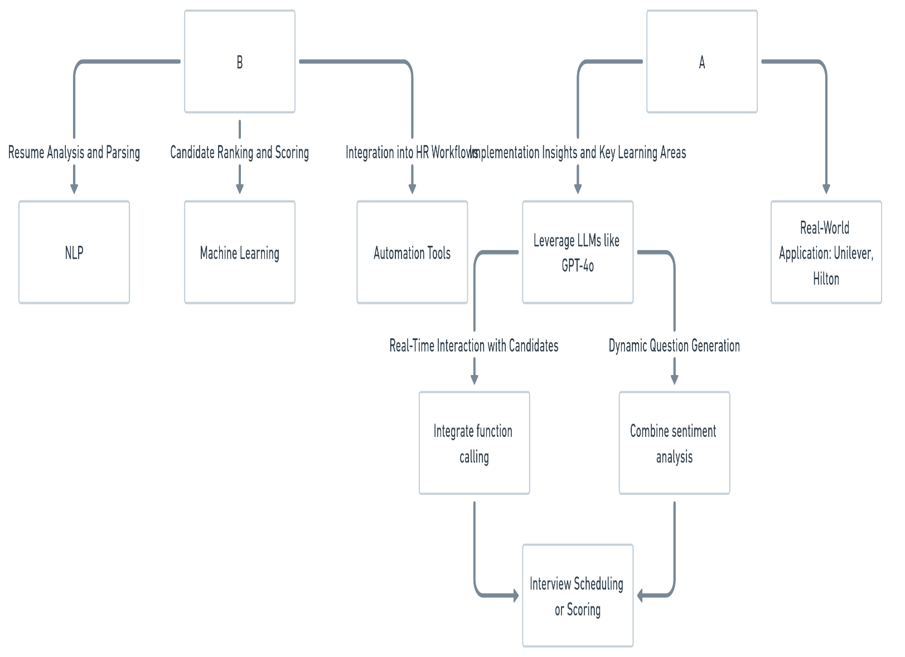

**FLOW CHART:**

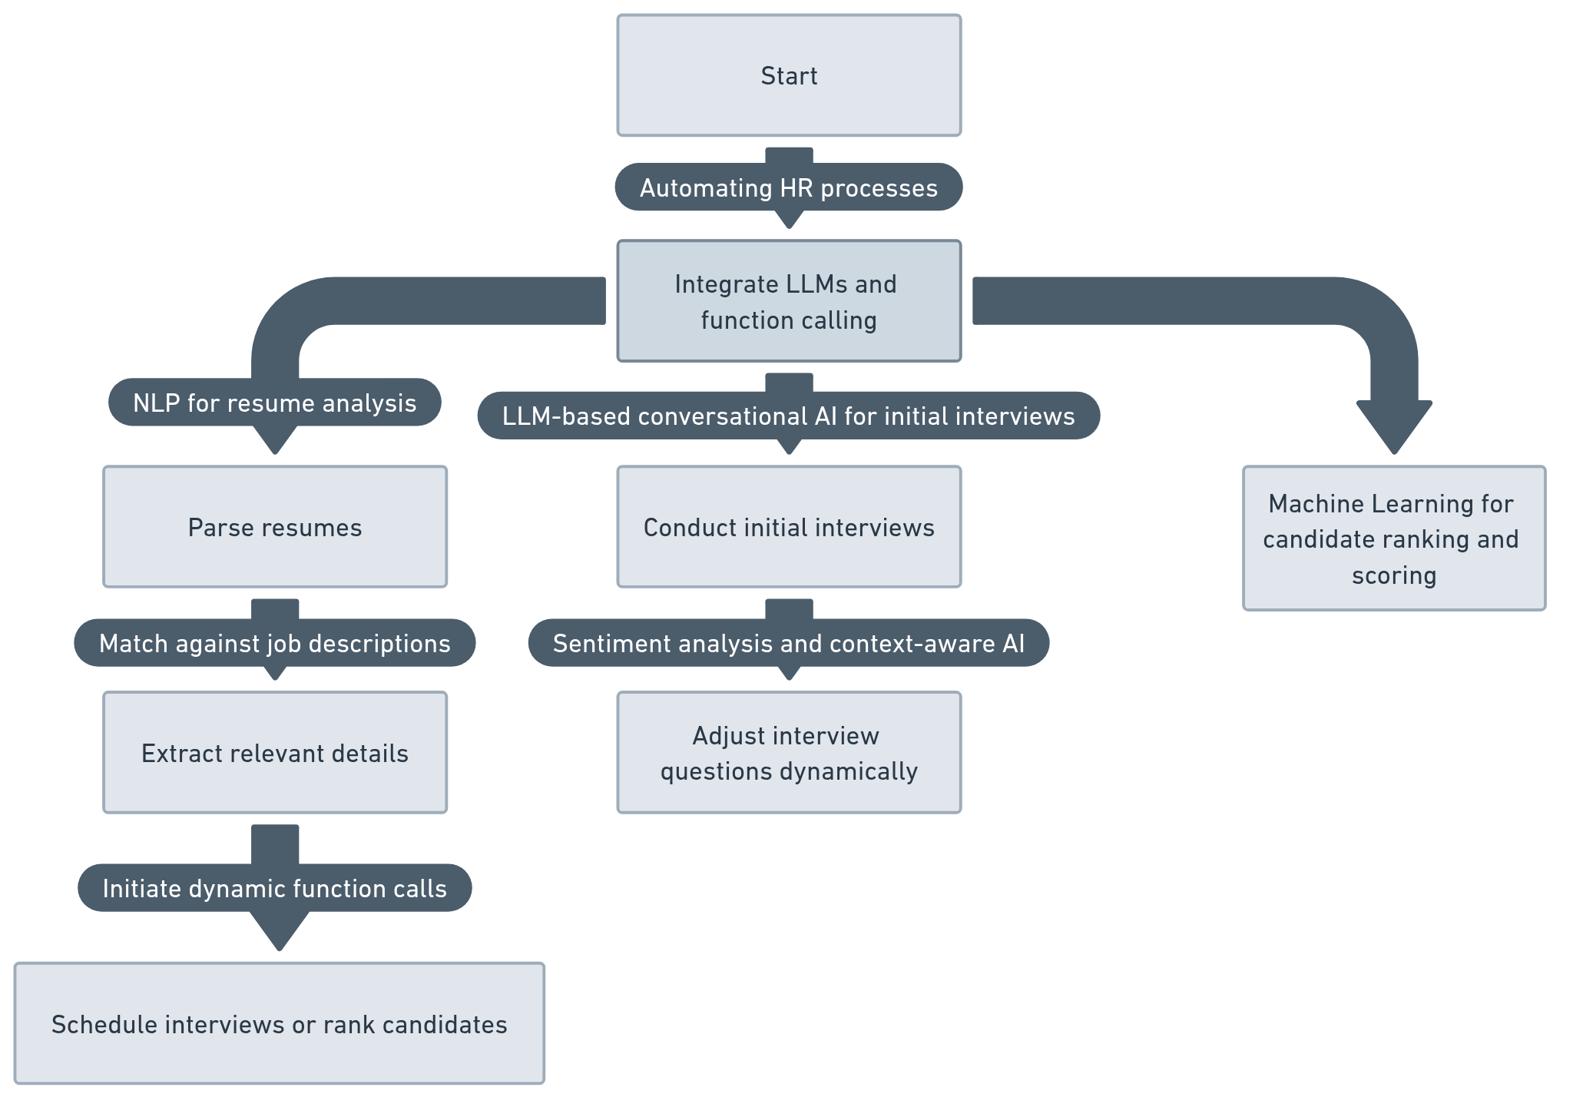

**Expected outcomes:**

1. **Implementation in other non IT sectors as well:**

Expanding the **Autonomous HR Agent** to **Healthcare, Education, Finance, Retail, and Manufacturing w**ill enable **accurate candidate screening, faster hiring**, and **attrition prediction accuracy**. AI-driven compliance checks will **reduce manual effort ,** while automated skill validation will improve **hiring efficiency .** This ensures **fair, data-driven, and optimized workforce management across industries**.

1. **Automated Interview conduction and evaluation:**

AI-driven **automated interviews** will reduce **manual evaluation time ,** ensuring **unbiased, data-driven assessments**. NLP and sentiment analysis will achieve **accuracy** in evaluating **candidate responses**, while facial & speech analysis will improve **non-verbal cue detection .** This will enhance **hiring efficiency, fairness, and decision-making speed**.

**References**

* Nawaz, Nishad, Hemalatha Arunachalam, Barani Kumari Pathi, and Vijayakumar Gajenderan. "The adoption of artificial intelligence in human resources management practices." *International Journal of Information Management Data Insights* 4, no. 1 (2024): 100208.

<https://www.sciencedirect.com/science/article/pii/S266709682300054X>

* S. Achchab and Y. K. Temsamani, "Artificial Intelligence Use in Human Resources Management: Strategy and Operation’s Impact," *2021 IEEE 2nd International Conference on Pattern Recognition and Machine Learning (PRML)*, Chengdu, China, 2021, pp. 311-315, doi:10.1109/PRML52754.2021.9520719.

https://www.researchgate.net/publication/356456817_Artificial_Intelligence_Use_in_Human_Resources_Management_Strategy_and_Operation's_Impact

<https://www.researchgate.net/publication/356456817_Artificial_Intelligence_Use_in_Human_Resources_Management_Strategy_and_Operation's_Impact>